Terraform Task -05
2). Execute the script shown in the video.

Create s3 using terraform:
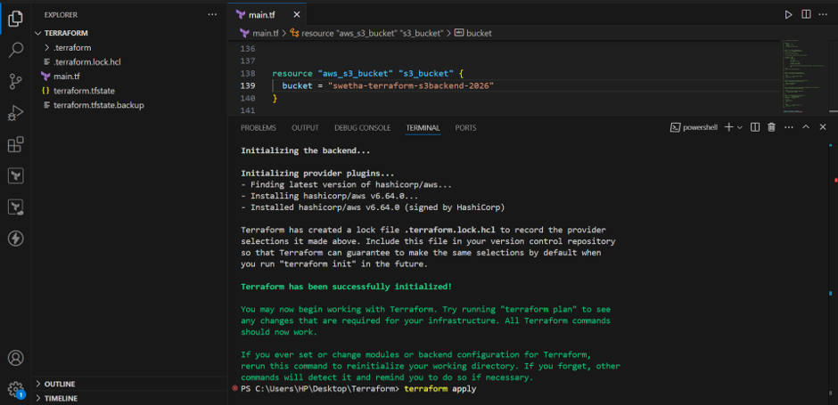
Verified bucket in AWS S3:

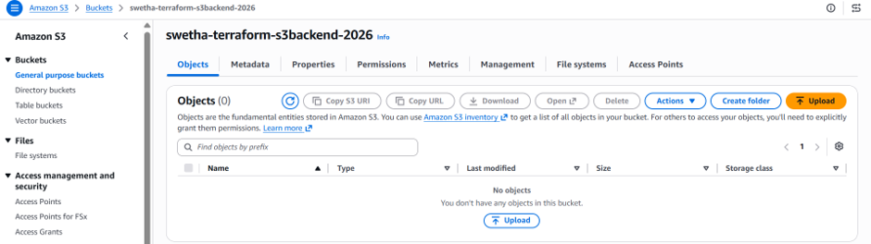

Create the DynamoDB table using Terraform

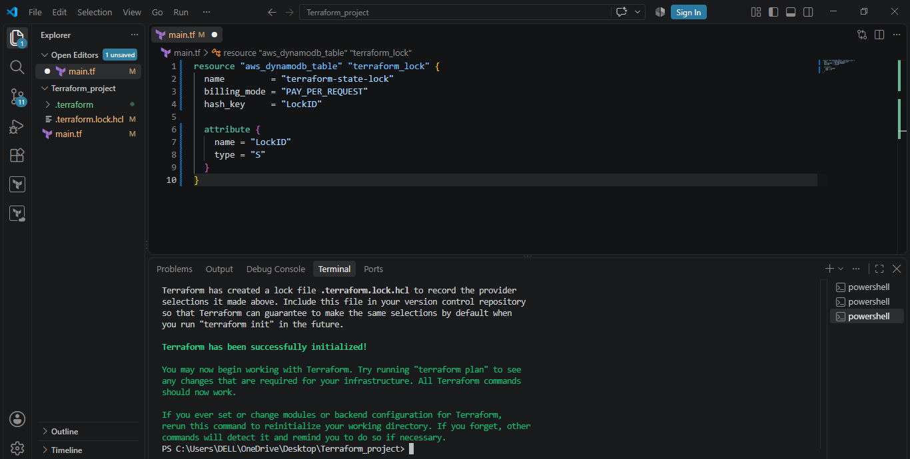

Step 2: Create the table

Run terraform init, terraform plan and terraform apply.

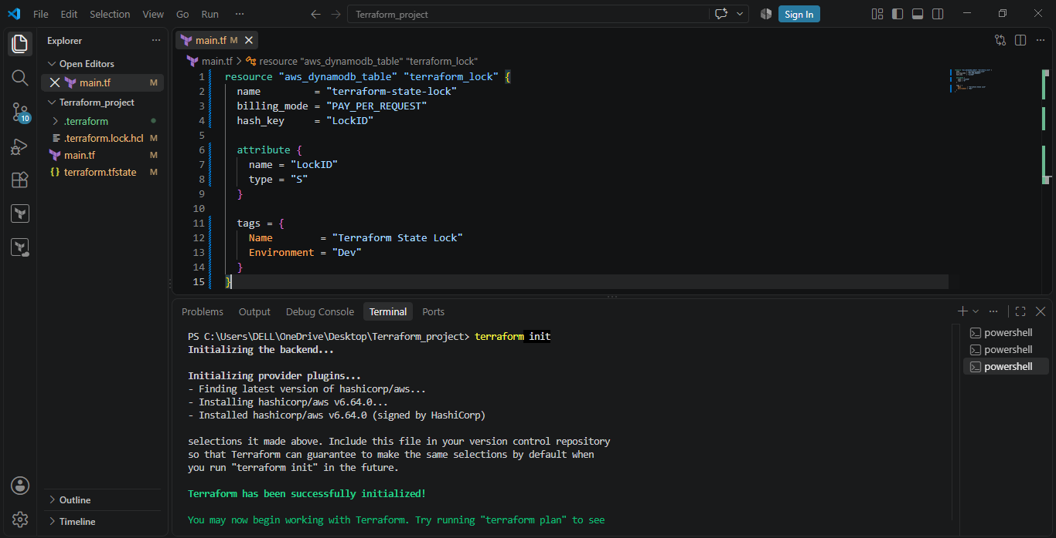

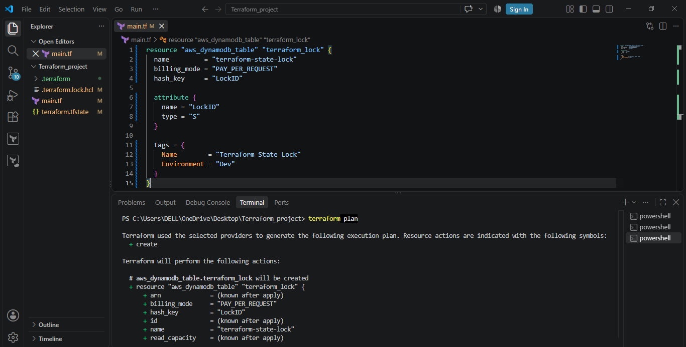

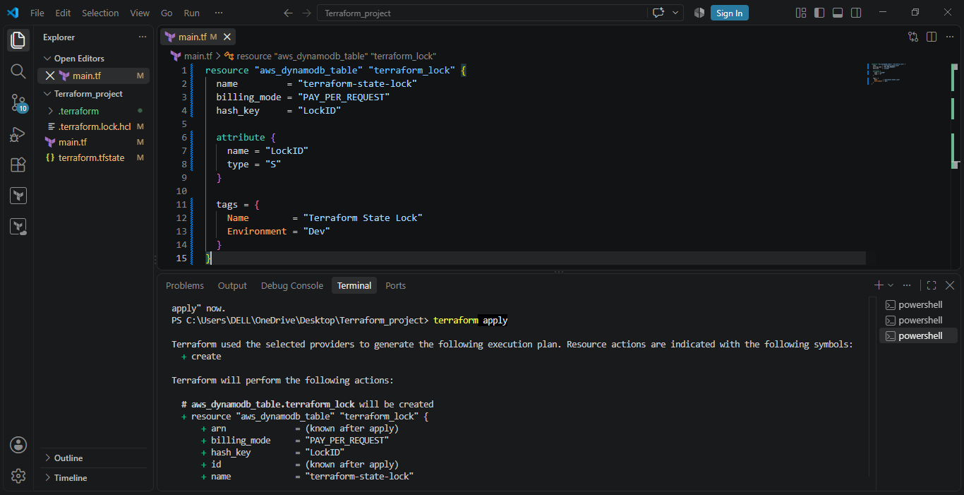

Verified in AWS that table is created:
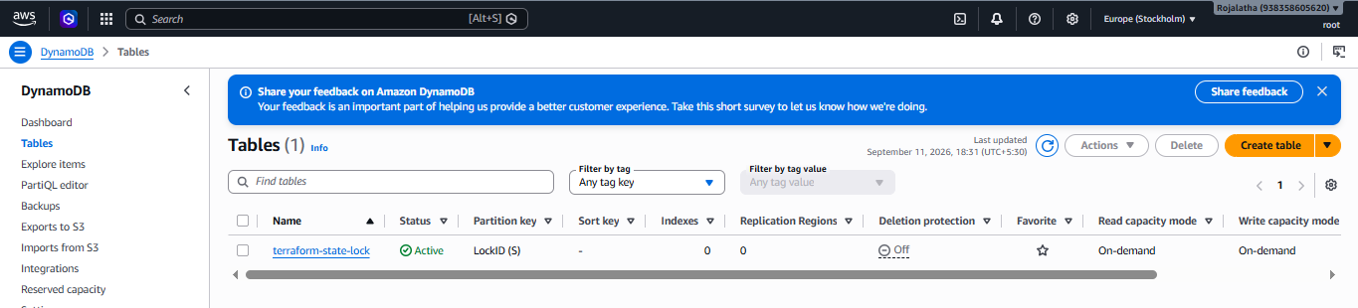
3). Create one EC2 instance with httpd installed using a Terraform script.

Step 1: Create main.tf
Initiate the repo, this downloads the AWS provider.

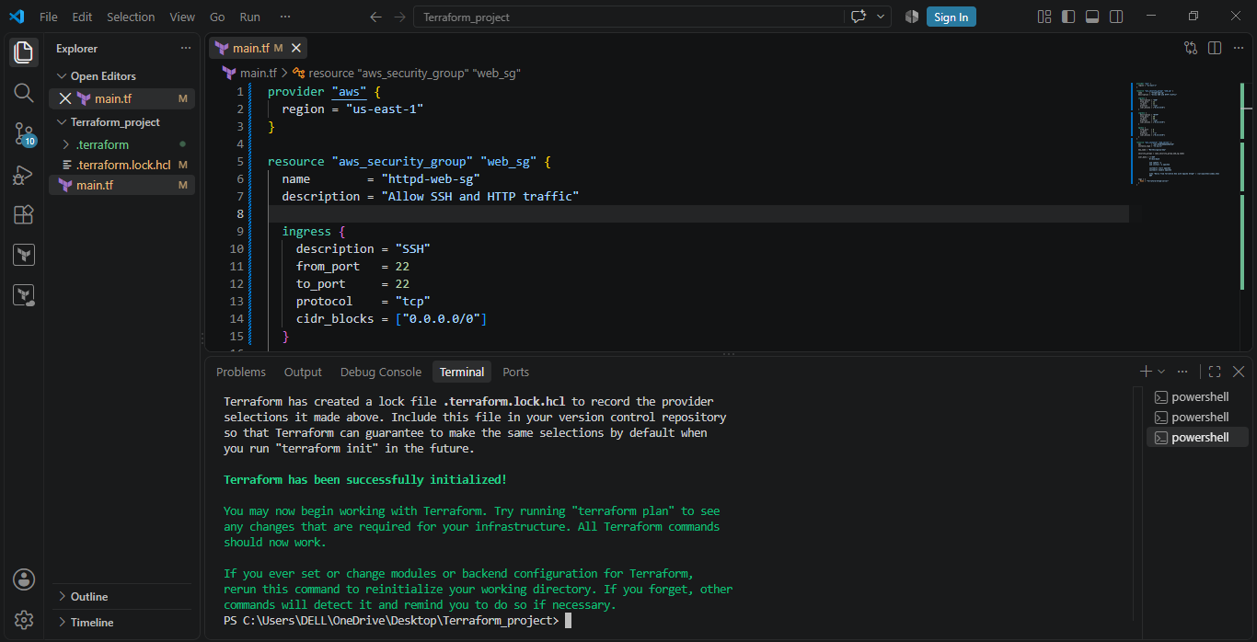

Step 2: Check the configuration, see what Terraform will create and create the EC2 instance

Using Terraform validate, terraform plan and terraform apply.
Terraform will create the EC2 instance.

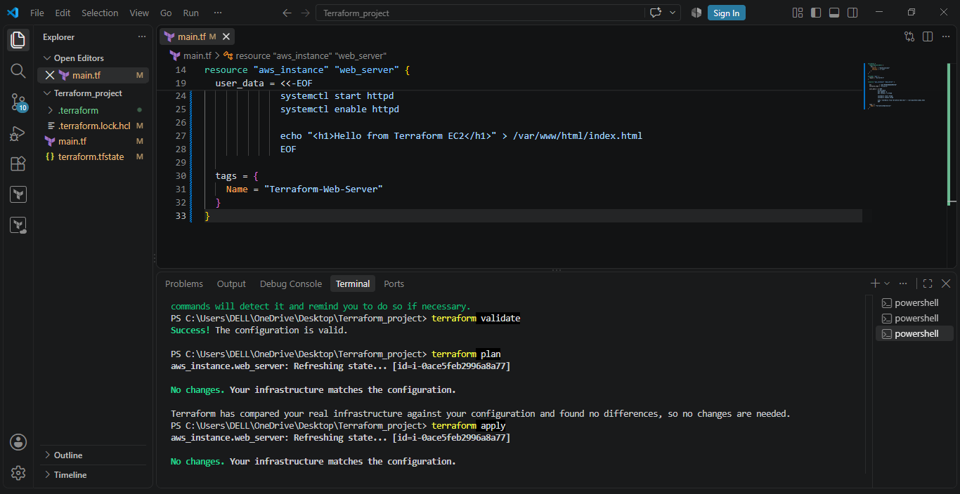

Verified that instance is created in AWS:

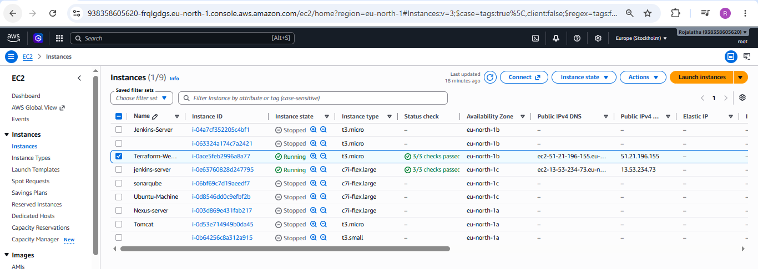

4). Set up S3 as backend for task 3.

Step 1: Create an S3 bucket
You can create the bucket from the AWS Console, or with AWS CLI.
Create a temporary file called main.tf:
Now run terraform init
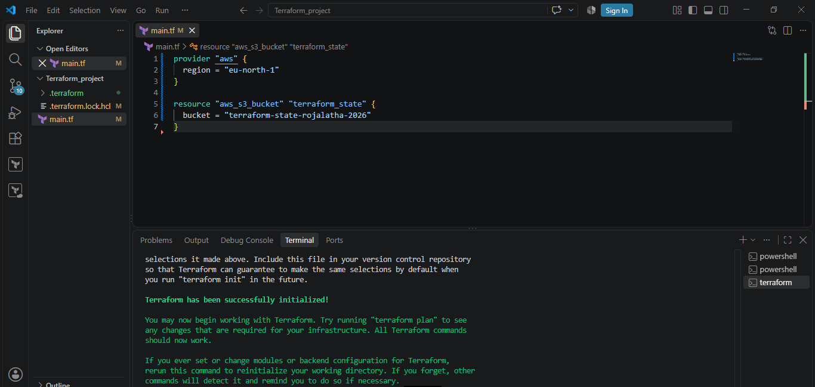
Then terraform validate, terraform plan and terraform apply
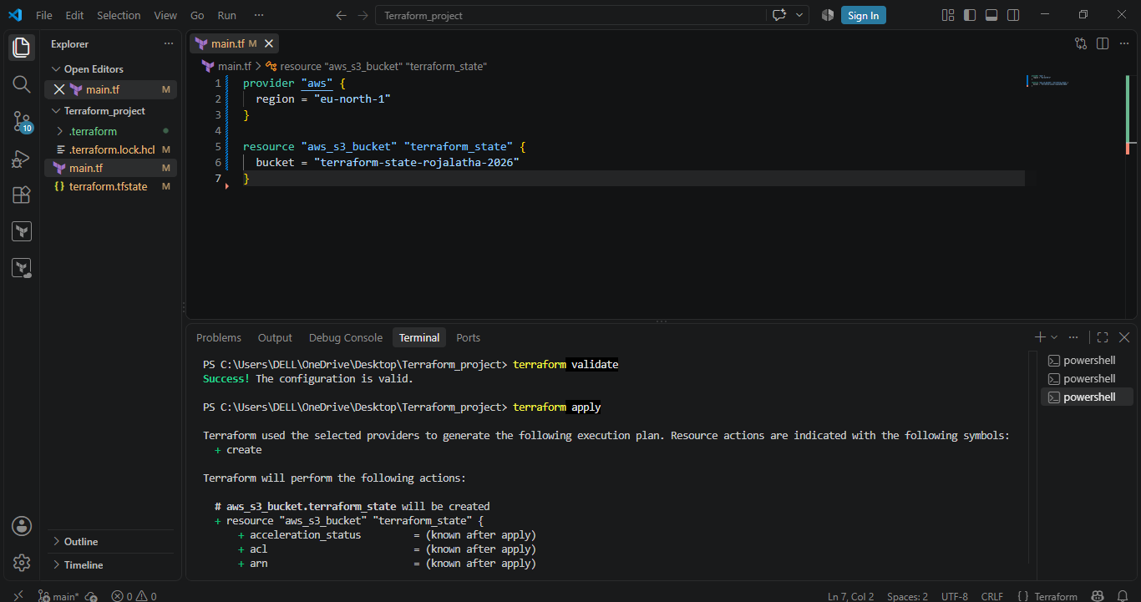
Now S3 bucket has been created by Terraform.
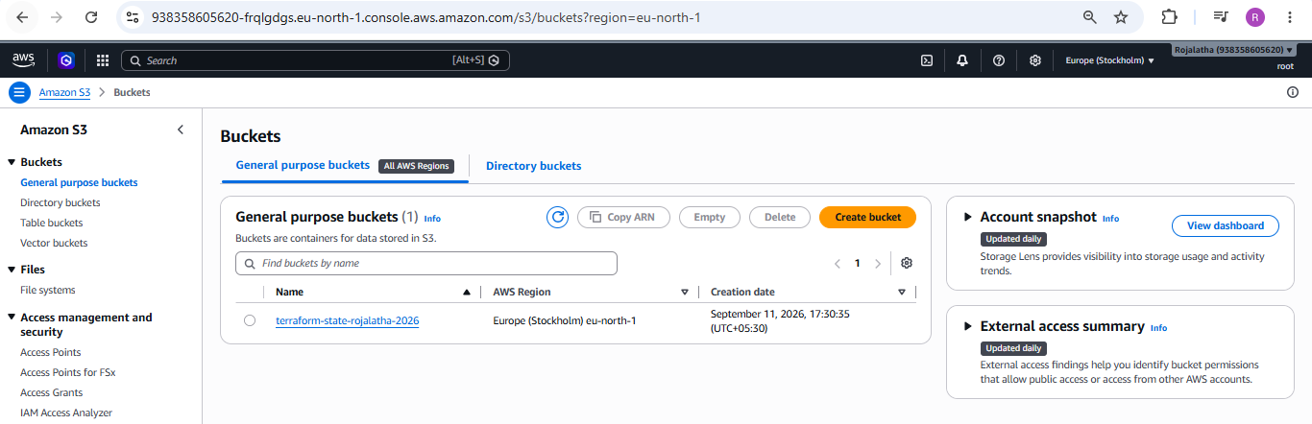
Step 2: Add the S3 backend
Add the below code to the main.tf file
terraform {
backend "s3" {
bucket = "terraform-state-rojalatha-2026"
key = "task3/terraform.tfstate"
region = "eu-north-1"
use_lockfile = true
}
}
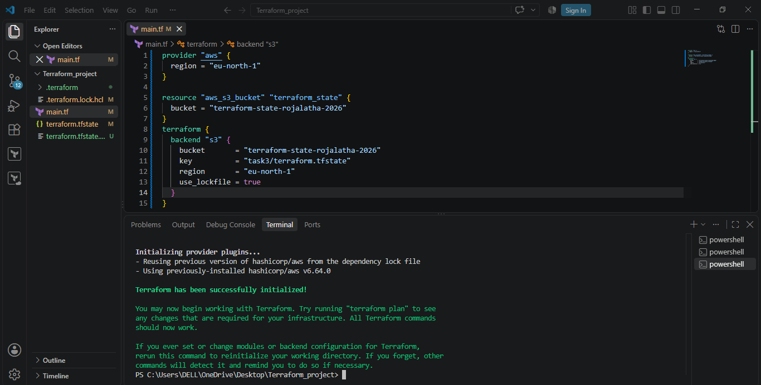

Step 4: Verify
Run terraform plan and terraform apply
After Terraform creates/updates resources, check your S3 bucket.
You should eventually see:
terraform-state-rojalatha-2026
|
└── task3/
|
└── terraform.tfstate

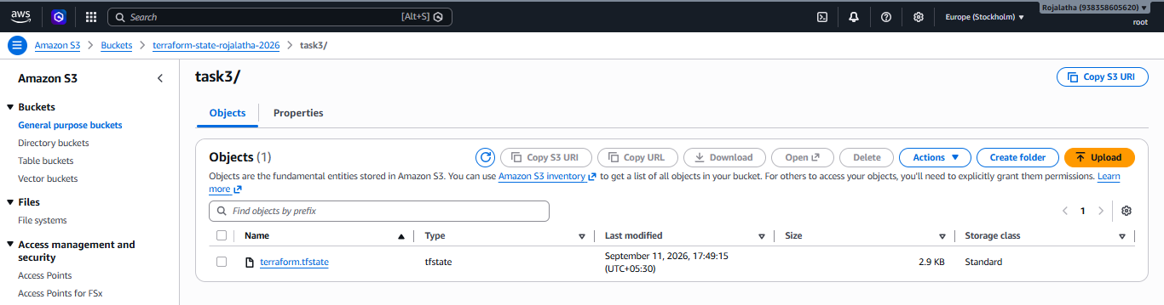
5. Set up DynamoDB locking for task 3.

Step 1: Create the DynamoDB table using Terraform

Create main.tf while and place the below script in the file
resource "aws_dynamodb_table" "terraform_lock" {

name = "terraform-state-lock"

billing_mode = "PAY_PER_REQUEST"

hash_key = "LockID"

attribute {

name = "LockID"

type = "S"

}

}
Terraform's DynamoDB locking mechanism expects the partition key to be named LockID.

Step 2: Create the table

Run terraform init, terraform plan and terraform apply.

Verified in AWS that table is created:

